Web Application for University Employees Records on Employment and Work Results

B. Radulovic, Lj. Kazi, B. Vujanov and A. Grgurovic
University of Novi Sad, Technical Faculty “Mihajlo Pupin”, Zrenjanin, Serbia
bradulov@tfzr.uns.ac.rs, leremic@tfzr.uns.ac.rs, bojanvujanov@gmail.com; kekivesna@sbb.rs

Abstract – Human resources management is one of very important segments in an organization, particularly higher education institution. This paper presents results about research in the field of human resources management. This paper also describes a web based based information system for human resources management, developed for Technical faculty “Mihajlo Pupin” in Zrenjanin, Serbia.

Introduction
Human resources (HR) in an organization, particularly in higher education institutions, create value for the benefit of society. Therefore, they present one of key resources of an organization. Management of these resources should be performed continuously and carefully.
One of the most important segments of human resources management (HRM) is the need for continual encouragement of employees’ improvements, such as knowledge and skills enhancements in continual education. In higher education institution, it is particularly important to establish the system of quality monitoring and improvements in the HRM segment. The key aspects in quality of higher education institution include three mayor segments:
- Education process, i.e. teaching,
- Scientific research,
- Implementing knowledge in society via projects.
For each of these segments, HRM needs to collect data and measure them according to standards, in aim to perform constant monitoring and decision support. This way, for each employee in higher education institution the quantity and quality of his/her results in each of these three segments are measured.
In aim to enable systematic collection and analysis of data, human resources information systems are developed. Usually they are created as web based systems, so employees could have access to the application for input and data retrieval.
This paper presents results of research in the field of human resources management, particularly for higher education institutions. This paper also presents web application developed in aim to enable electronic employees records on employment and work results in higher education institution. It was developed particularly to be used at Technical faculty “Mihajlo Pupin” Zrenjanin, University of Novi Sad, Serbia (TFZR), but it could be used by any higher education institution.

Criteria for organization efficiency measurement
Human resources management is segment of management of institution. Management of an organization should be based on measurement of performance. In aim to enable measurement of efficiency and effectiveness, it is important to define criteria for measurement.
“Criteria problems are the major obstacles to the empirical assessment of organizational effectiveness, and they are of two general kinds. The first relates to the selection of the type of criteria indicating effectiveness, and the second relates to the sources or originators of the criteria. Problems of criteria type generally focus on:
(1) the aspect of the organization being considered, e.g., goal accomplishment, resource acquisition, internal processes,
(2) the universality or specificity of criteria,
(3) the normative or descriptive character of criteria,
(4) the static or dynamic quality of criteria.” [1]
There are several most used approaches in criteria selection in organizational effectiveness measurement [1]:
- Outputs and goal accomplishment criteria;
- Interaction of the organization with its environment - organizational effectiveness as the ability of the organization to exploit its environment in the acquisition of scarce and valued resources.
- Criteria based on internal organizational processes by which organizations articulate preferences, perceive demands, and make decisions.

The role of human resources management
Becker and Gerhart [2] present the role of human resource decisions in creating and sustaining organizational performance and competitive advantage. “A central feature of many human resource decisions is information on employee and organizational performance.” [3]
"Human resources, both as labor and as a business function, have traditionally been viewed as a cost to be minimized and a potential source of efficiency gains.” [2] “Very seldom have HR decisions been considered a source of value creation. The new interest in human resources as a strategic lever that can have economically significant effects on a firm's bottom line, however, aims to shift the focus more toward value creation.”[2] “The resource-based view (RBV) of the firm has influenced the field of strategic human resource management (SHRM)” [4]. Figure 1. presents the strategic HRM components.
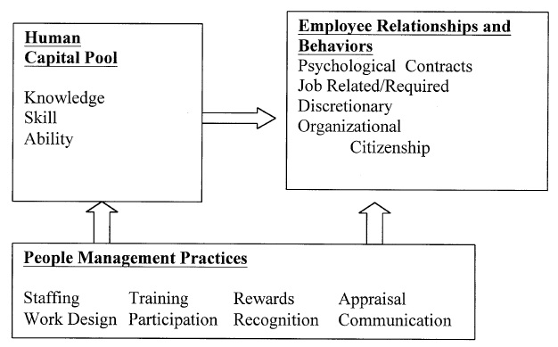
- Model of the basic strategic HRM components [3]
“HR system can be a unique source of sustained competitive advantage, especially when its components have high internal and external fit." [2] “Developing and implementing human resource management strategies incorporate both an external fit (human resource management fits the developmental stage of the organization) and an internal fit (the components of human resource management complement and support each other).” [5]
To implement HRM, McGregor [6] emphasizes the human aspect of organization, i.e. taking care of certain human needs: psychological needs, safety needs, social needs, ego needs, self-fulfillment needs. One of important aspects of HRM and role of management is motivating employees. In aim to consider these needs, McGregor [6] suggests management techniques such as: decentralization and delegation of responsibility, participation and consultative management and performance appraisal.

Scientific an technical human capital and productivity

Bozeman et al [7] present "scientific and technical human capital (S&T human capital) model that could be applied in companies. This model gives less attention to the discrete products and immediate outcomes from scientific projects and programs (which are the usual focus of evaluations) and gives more attention to scientists' career trajectories and their sustained ability to contribute and enhance their capabilities. S&T human capital encompasses not only the individual human capital endowments but also researchers’ tacit knowledge, craft knowledge, know-how. S&T human capital further includes the social capital that scientists continually draw upon in creating knowledge—for knowledge creation is neither a solitary nor singular event.” [7]
Moreover, Dietz and Bozeman [8] examine academic researchers’ careers comparing with industry researchers careers. The key findings that industry researchers are more productive in patents, while employees from university research centers are more productive in publication. Grants and funding are considered [8] as one of important reasons for such situation. Dietz and Bozeman suggest more close collaboration between university and industry, as well as more frequent personnel exchange. “Some public policies promote movement back and forth between industry and universities and others promote active collaboration or personnel exchange” [8]. “If government policy chooses to focus on the commercial productivity of academic institutions, as seems to be the policy trend, then there is reason to believe that the solution may be human capital in nature. The hiring of researchers with industrial job experience and, perhaps, visiting positions and exchanges with industry may be a productive means of boosting the commercially relevant innovation of universities.” [8]
Even Dietz and Bozman [8] relate scientific productivity with funding and grants support, Leta, Lannes and De Meis [9] present results of funding impact to scientific productivity.“The data presented indicate that even in a period of economic crisis, a selective investment of funds in human resources may lead to an increase of the scientific productivity of a country in all science fields”. [9]

Human resources information systems
Human resource management information systems (HRIS) are considered as computer based tools in HRM. “HRIS systems have evolved into complex tools designed not only to manage a rich variety of information about the firm's human capital, but to also provide analytical tools to assist in decision making about the management of those assets.” [10]. According to the size of an enterprise, HRIS capabilities are presented at Figure 2.

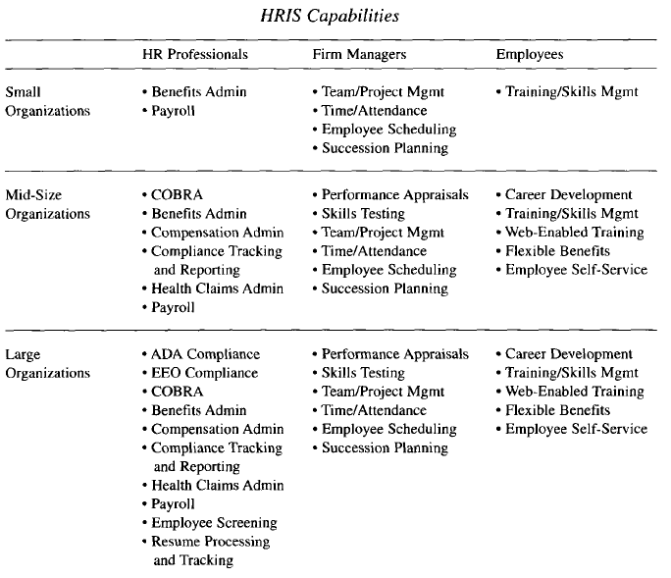
- HRIS capabilities, depending on an organization size [10]
Kossek et al [11] presents required HRIS capabilities:
- Compensation and benefits
- Recruitment and selection
- Affirmative action
- Performance appraisal and career planning
- Payroll operations
- Strategic HR and HR planning
- Employee/labor relations
- Productivity monitoring (e.g. absence, turnover, labor costs)
- Personnel research (e.g. surveys) and organization development
- Training and development.

Web Application for University Employees Records at TFZR
HRIS are usually implemented as a desktop application, to be used by human resources department of an organization. Interaction with employees in data entry requires technologies such as web and mobile applications.
This section presents results of implementation of web application for human resources records (HRR) at Technical faculty “Mihajlo Pupin” Zrenjanin, University of Novi Sad. The HRR web application is implemented with menthorship of Ljubica Kazi and co-menthorship of Biljana Radulovic.
The developed web application consists of two parts – modules, which are developed as separate solutions, by using MS Visual Studio 2010 and SQL Server 2008 R2. These two parts are:
- Employment records web application (author: master student Bojan Vujanov),
- Work results records web application (author: master student Aleksandar Grgurovic).
The developed solution is specific, since it is focused on particular needs of higher education institution. Special concerns are related to government funding university school in Serbia. The process of employment is aligned to the regulations particularly for this type of higher education institution. Data collection is performed according to the standards regulations and document forms [12] that are used in the process of employment of academic teaching and research staff.

Web application for employment records at TFZR

Employment at government funding higher education in Serbia is contract-based for all employees, except full professors. Web application for employment records is developed in aim to support employment business pocess through all important phases.
First phase is employment initiation. The process of employment starts with determination of contracts expiration as well as needs for new employees, if new segments of educational and research activities are developed within educational institution. Web form for the presentation of the data about contract expiration is developed within this web application (Figure 3).

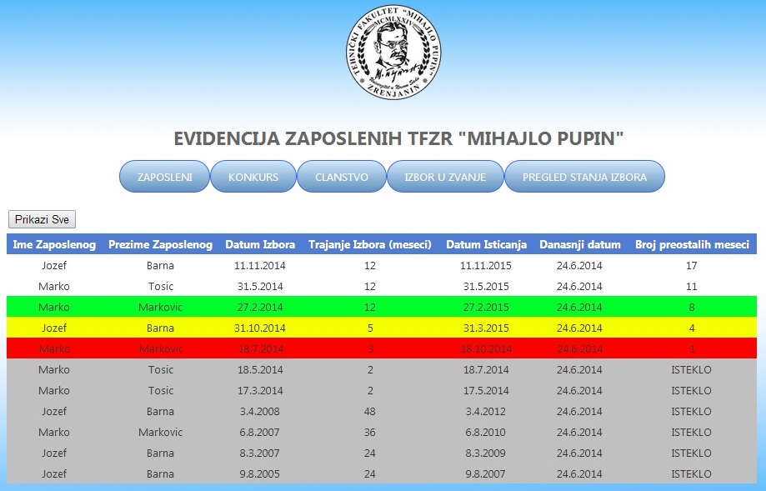

- Web form with tablular presentation of status of all employees regarding contract expiration
Second phase is starting the process of employment by adding new job advertisement (ad) , which will occur at institution web page as well as in official newspapers “Poslovi”. Web page for entry of data related to creating new ad is presented at Figure 4.

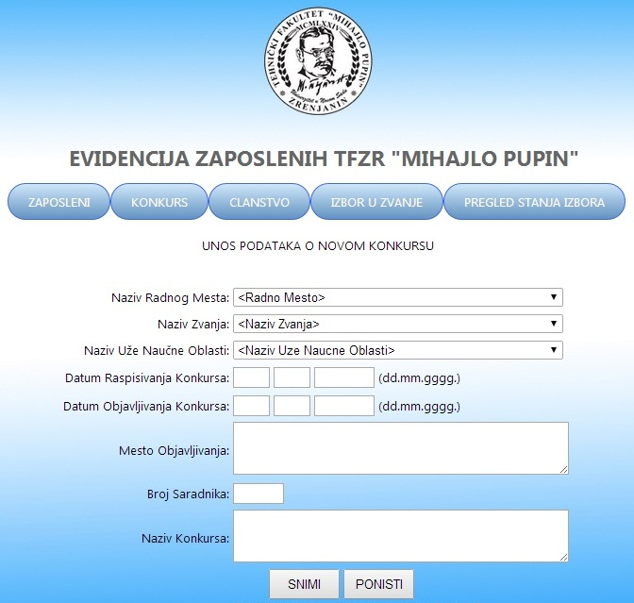

- Web form for new job advertisement data entry
Finally, after selection of a candidate, contract is signed according to decision about election to particular position according to previous ad. Web form for data entry regarding election of a person to employment at certain position is presented at Figure 5.
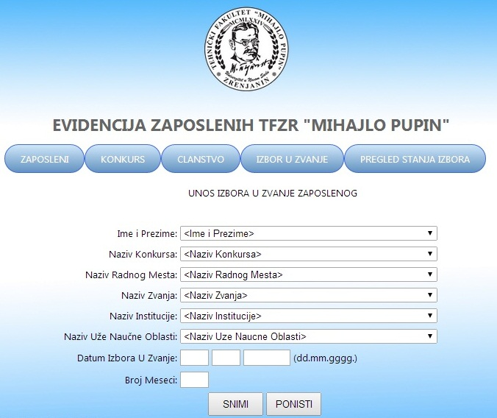
- Data entry form related to data about election to position
Each data entry web form has appropriate tabular representation.
Finally, data regarding election are used within the “status” form (Figure 3), where critical data are market with red color (less than 3 months left until contract expiration), yellow is for less than 6 months, and green are less than a year. Gray coloured are rows with the dates that already expired.

Web application for work results records
Work results at University school are related to academic achievements in science such as published books, papers at conferences and journals, projects etc. Existing solutions in Serbia in this field include partial support to scientific records:
- Kobson system [13], which presents results of scientific publications recognized by Thomson ISI master journal list [14] and conference publications.
- Serbian SCI system – Serbian citation index [15], with certain records about publications.
- Web application KNR (Records of scientific worker) [16]. Using this system requires centralization in certain data approvements and verification, which leads to certain dependency in data entry.
Having official web applications considered not complete and not always available for data entry, development of separate institution-based application could be considered as appropriate and needed.
Web application that enables data entry and retrieval regarding scientific and other work results of higher education institution employee is developed to be extensible. It is possible, since database is designed with IS-A hierarchy of results data table and particular result types data. This IS-A database design is also supported by Multi View control in user interface. Figure 6. presents data entry form that uses Multi view. After selection of result type from drop down list at the left side of web page, then automatically at the right side appears multi view panel with details to be entered regarding the choosen type of result.
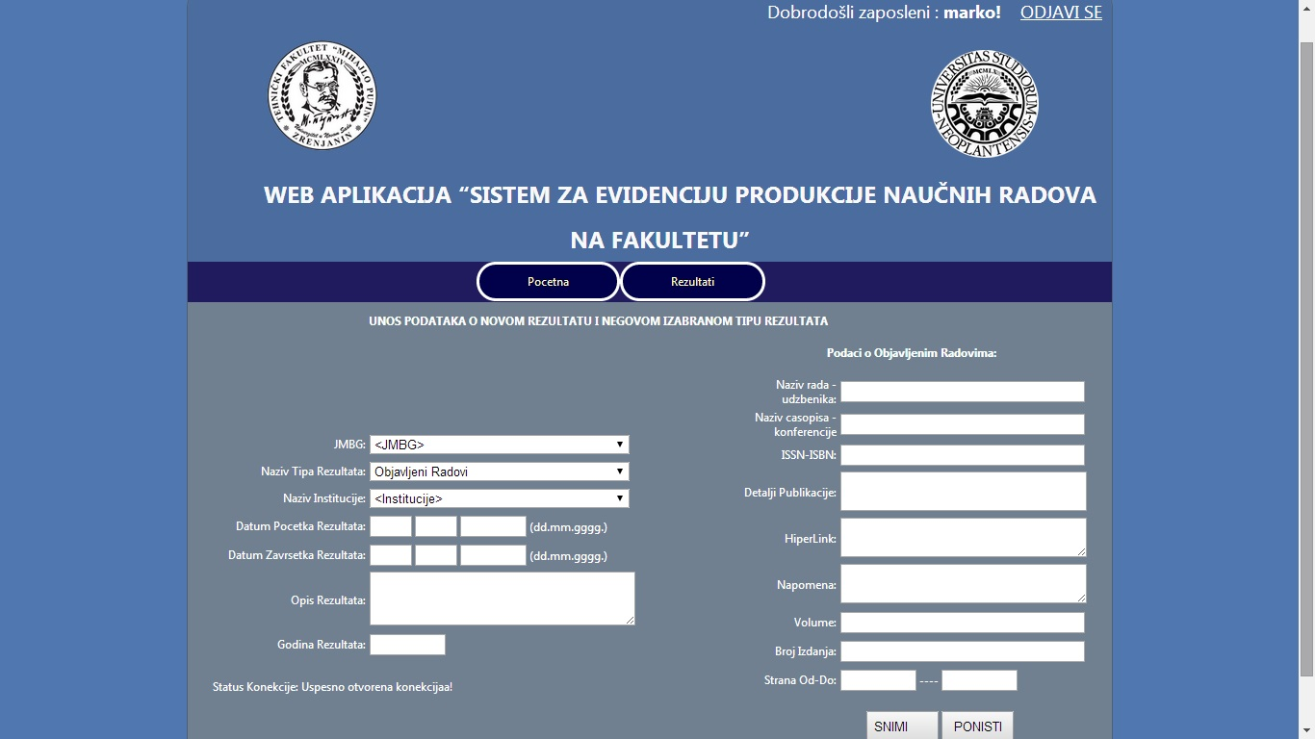
- Data entry about work results with Multi View
Figure 7. shows tabular presentation of all results at the left side of web page. When user selects particular row, automatically at the right side of the page appears multi view panel with details about the selected item.
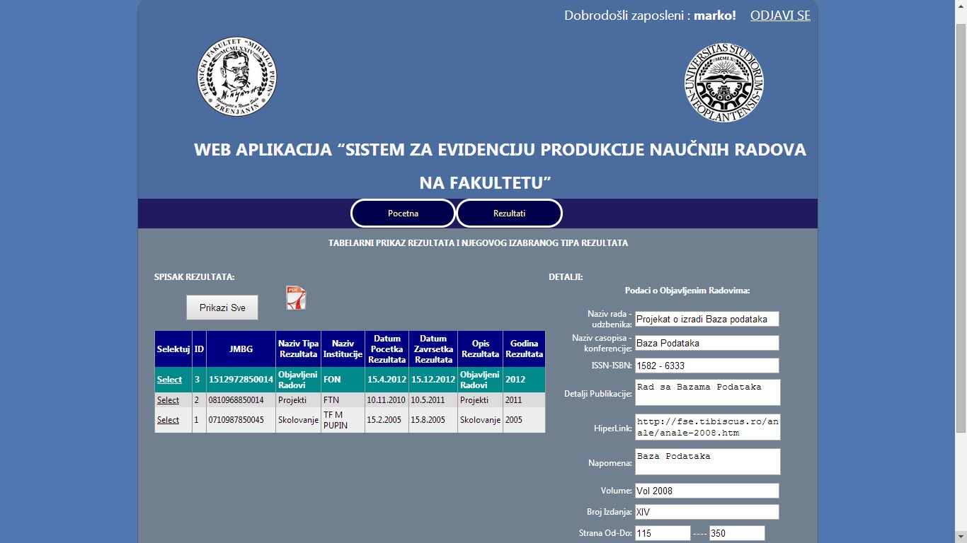
- Data retrieval in tabular form with work results presentation and multi view with details presentation
The page with data retrieval also enables data export in the form of PDF document.

Conclusion
Human resources management is very important segment of management, since human resources are the ones that produce value. HRM should be particularly carefully performed in the field of higher education institutions. IT support in the field of human resources management enables efficiency of HR department, as well as decision support.
This paper presents web application developed to be support to human resources department at Technical faculty “Mihajlo Pupin” Zrenjanin, University of Novi Sad. This application is particularly oriented towards needs for data entry and retrieval regarding government funded higher education in Serbia. Specific benefits of the developed solution enable monitoring of the status of employees’ contracts expiration and scientific results records. This way, the developed solution enables data entry and retrieval, as well as decision support in particular and precise way.
The developed solution could be more improved particularly in the field of statistics that could be basis for decision support.

References

- K. Cameron, “Measuring Organizational Effectiveness in Institutions of Higher Education”, Administrative Science Quarterly, Vol. 23, No. 4 (Dec., 1978), pp. 604-632
- B. Becker, B. Gerhart: “The Impact of Human Resource Management on Organizational Performance: Progress and Prospects”, The Academy of Management Journal, Vol. 39, No. 4 (Aug., 1996), pp. 779-801
- S. Loeb, A. Paglayan, E. Taylor, “Understanding Human Resources in Broad-Access Higher Education”, In: Remaking College: Broad-Access Higher Education for a New Era, NYU Steinhardt School of Culture, Education and Human Development, November 29-30, 2012
- P. M. Wright, B. B. Dunford, S. A. Snell, “Human resources and the resource based view of the firm”, Journal of Management 27 (2001) 701–721
- L. Baird, I. Meshoulam: “Managing Two Fits of Strategic Human Resource Management”, The Academy of Management Review, Vol. 13, No. 1 (Jan., 1988), pp. 116-128.
- D. M. McGregor, “The Human Side of Enterprise”, Management Review, November 1957, pp. 41-49.
- B. Bozeman, J. Dietz, M. Gaughan, “Scientific and Technical Human Capital: An Alternative Model for Research Evaluation”, presentation at the American Political Science Association, September 5, 1999, Atlanta, Georgia
- J.S. Dietz, B. Bozeman, “Academic careers, patents, and productivity: industry experience as scientific and technical human capital”, Research Policy 34 (2005) 349–367.
- J. Leta, D. Lannes, L. De Meis, “Human Resources and scientific productivity in Brazil”, Scientometrics, Vol. 41, No. 3 (1998.) 313-324.
- A R. Hendrickson, “Human Resource Information Systems: Backbone Technology of Contemporary Human Resources”, Journal of Labor Research, Volume XXIV, Number 3 Summer 2003
- E.E. Kossek, W. Young, D.C. Gash, V. Nichol, “Waiting for Innovation in the Human Resources Department: GODOT implements a Human Resource Information System”, Human Resources Management, Spring 1994, Vol 33, No 1, pp. 135-159
- University of Novi Sad official web page, documents and regulations list, http://www.uns.ac.rs/sr/
- Kobson system, http://kobson.nb.rs/
- Thomson ISI, master journal list, http://ip-science.thomsonreuters.com/mjl/
- Serbian citation index, http://scindeks.ceon.rs/?lang=en
- Records of scientific worker, for University of Novi sad, http://knr.uns.ac.rs/

